**Rugby Kicking Web App**

**Introduction**

The Rugby World Cup started a week ago, and much has been made of the amount of goal kicking we have seen so far in the opening weekend. In the first match between contenders France and New Zealand, the French were happy to continue to kick for goal. We saw a similar strategy from England, and the South African team in a tight contest because they kept missing their kicks at goal when they played Scotland.

As all things rugby, there are very few plays called by the coach, as the players on the field do not have a lot of communication with their coaching staff. The South African Springboks found an [ingenuitive way](https://www.independent.co.uk/sport/rugby/rugby-union/south-africa-traffic-lights-rugby-world-cup-b2411570.html) to communicate from the coaches box down to the field by holding up a light, yellow to kick for points, red to go for the corner and try for a line out. Part of that decision now is analytical from the coaches, being able to calculate the probability of a successful kick based on the location of the field.

For this small analysis, I scrapped [data](http://www.goalkickers.co.za) which had both conversions (the extra points after a try), and penalty kicks. This data was collected from the English Premiership. So while these are not world cup games, many of the players from various World Cup Squads had data in the sample, and these players are all very high quality players, so the assumption of similarity in skill I believe holds although they were not taken from World Cup matches and there are nations in the world cup who do not have players who play in the Premiership.

**Methodology and Discovery:**

After scraping the data, as seen below, (image of field created in plotly).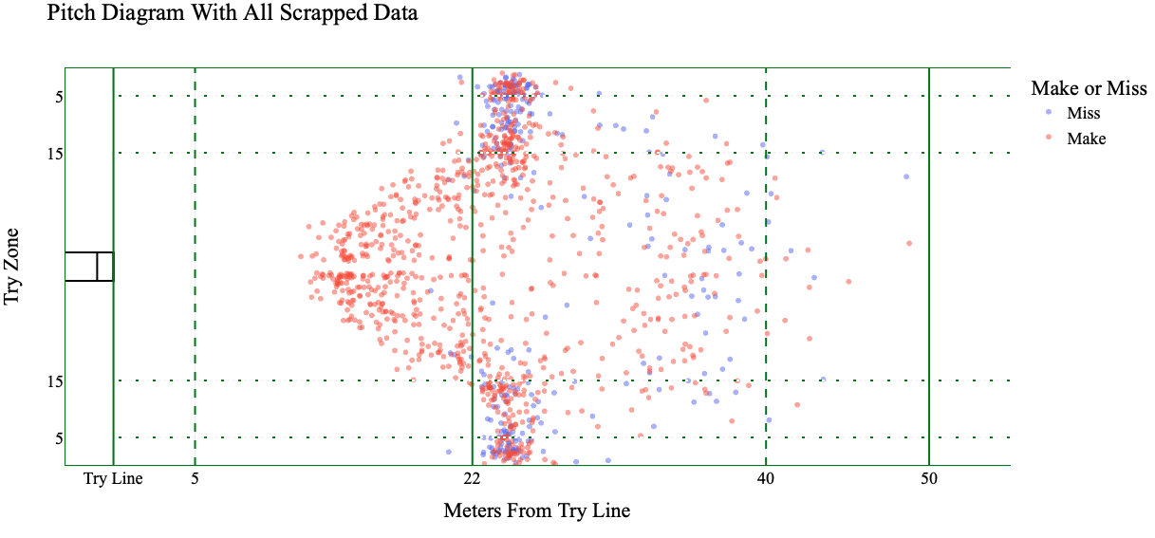

I was curious to see if there were significant insights to be gained from clustering. If there were perhaps key areas where kicks were usually taken from.

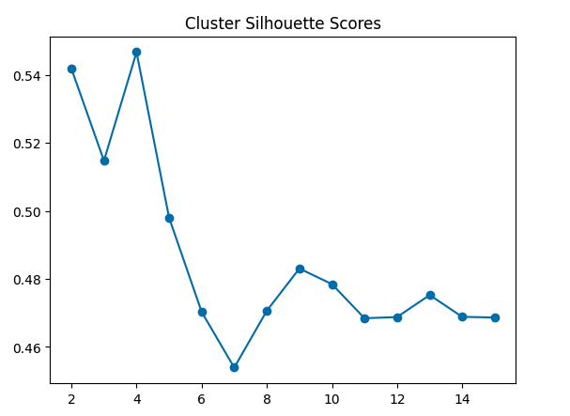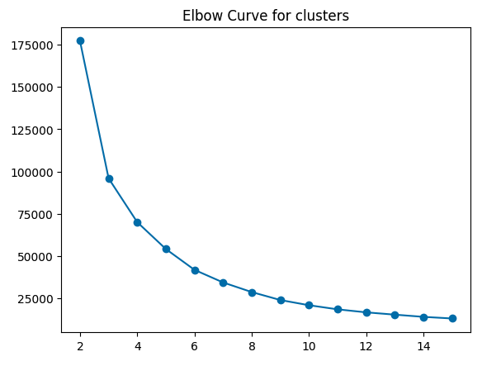

As seen from the scatter plot above, there are not really well defined clusters, and we see that in the Silhouette scores, where the highest score is at 4 clusters. The silhouette score essentially measure how separable the clusters are, and in the elbow curve measuring the inertia, there is perhaps a slight elbow at 4, but nothing super major. This goes to the fact that there is a density of kicks taken from right in front, when the probability of making the kicks are very high, and then out of necessity on the side lines from tries scored in the corners. Outside of that, the data were not very centrally located and therefore did not provide clear clusters.

**Modeling**

Having examined this, I wanted to build a logistic classifier that could then give me the probabilities of kicking for goal. I built a boosted model, where the hyper parameter selection was done in a randomized grid search for optimal learning rate, estimators, depth and include cross validation. When choosing an outcome metric, I decided to use ‘F1’. I wanted to weigh both the type 1 and type 2 errors equally, not wanting to always predict makes, or be too pessimistic that I would never kick for goal. After building the boosted model using SkLearn, I wanted to compare it to a non-boosted logistic regression. In this Roc Curve, we can see that the True positive rate for the boosted classifier goes much higher and plateaus around .6 of the false positive rates and doesn’t really improve. Having shown that our boosted classifier was indeed doing better than a vanilla logistic classifier, I took the test set that had been held out of training and used that to make a prediction map and use the probability as my heat map. 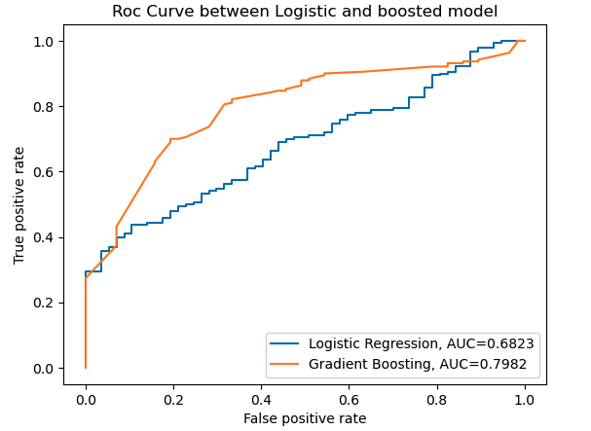

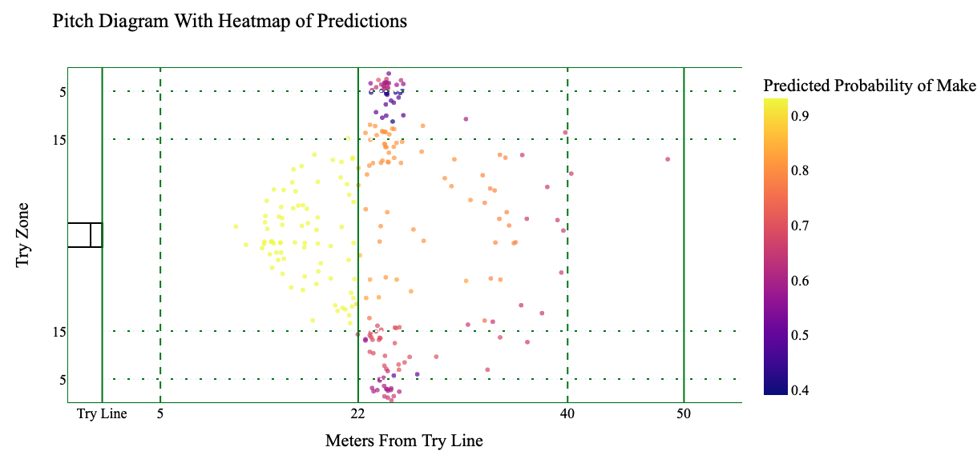

We get a very obvious result, but a result we expected to get, the closer you are to the poles, and the more central the kick is taken from, the higher the probability. No kicks from the edge are taken from inside the 22 as the angle is too difficult to convert. The sacrifice of proximity to the poles opens the window for the kicking. We also find that kicking from the right touch line is more difficult than the left touch line. As most kickers are right footed, the slight angle adjustments needed to kick from the right touch line vs the left touch line are enough to see a decrease in probabilities of success along the different touch lines.

If you are at home and wanted to calculate the probability of any location on the field, I put this program on git hub and built a streamlit app. A user can go in, examine the scrapped data and the heat map above, (both of which are interactive, made with plotly) and then put in coordinates on the field and get out a probability of success.

For accuracy metrics, we used F1 as our outcome variable, not wanting to only predict makes or be too risk averse. This is the confusion matrix showing the different accuracy metrics for the different classes.

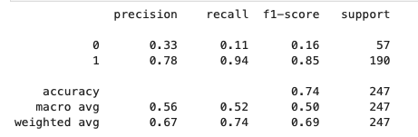

**Potential limitations:**

As mentioned before, the data that I scrapped was not from the World Cup, and as a result, it is possible that certain nations, particularly tier 2 nations, do not kick at as high a level. The kicking data did not account for the score in the match, or the time the kick was taken. A kick for goal in the 10th minute of a 0-0 game is likely very different than a kick in the 80th minute to win the game. This is a flaw that could not be helped given the data.

Thanks for reading.

James Griffin-Gomez

385.539.9262

[jamesgriffd@gmail.com](mailto:jamesgriffd@gmail.com)